Worksheet1

Repository

A repository is the place where the history of your work is stored, where you can see all the changes that were made, step by step.

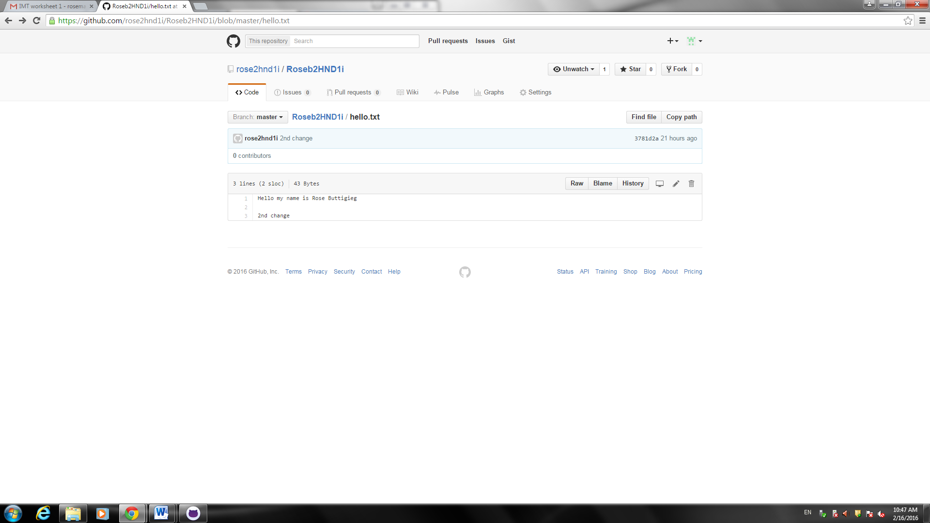

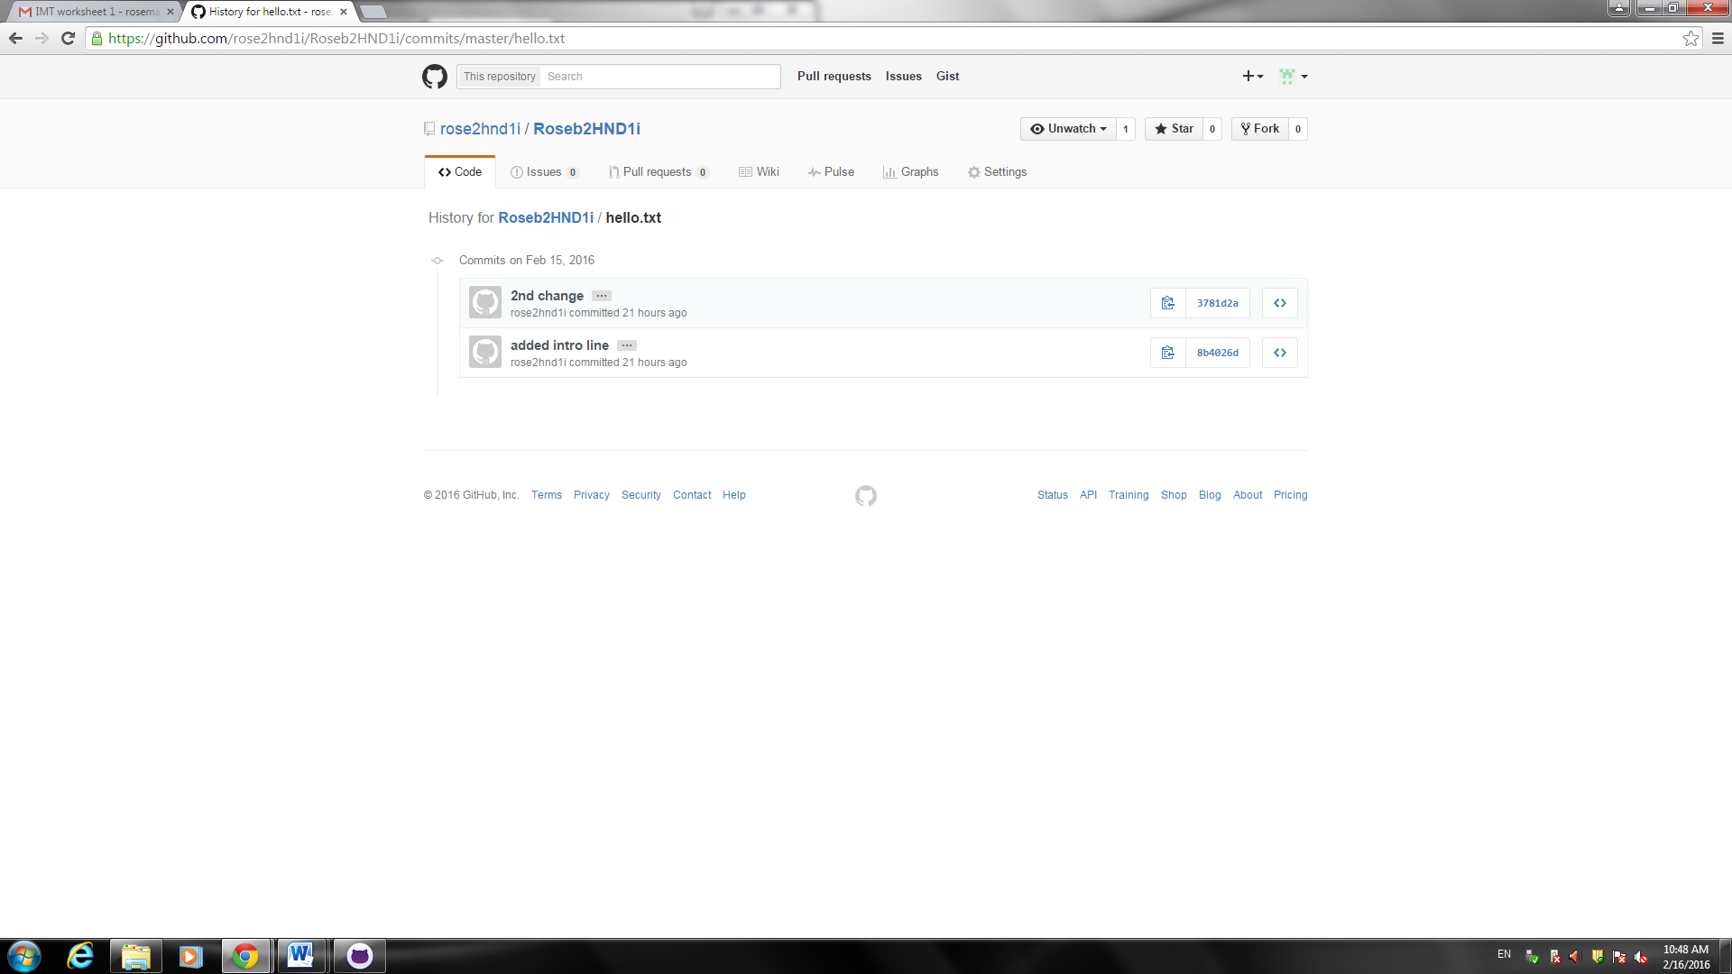

Commit

When you commit a file, it is like saving a file, but it also allows you to keep a record of the changes made and by whom.

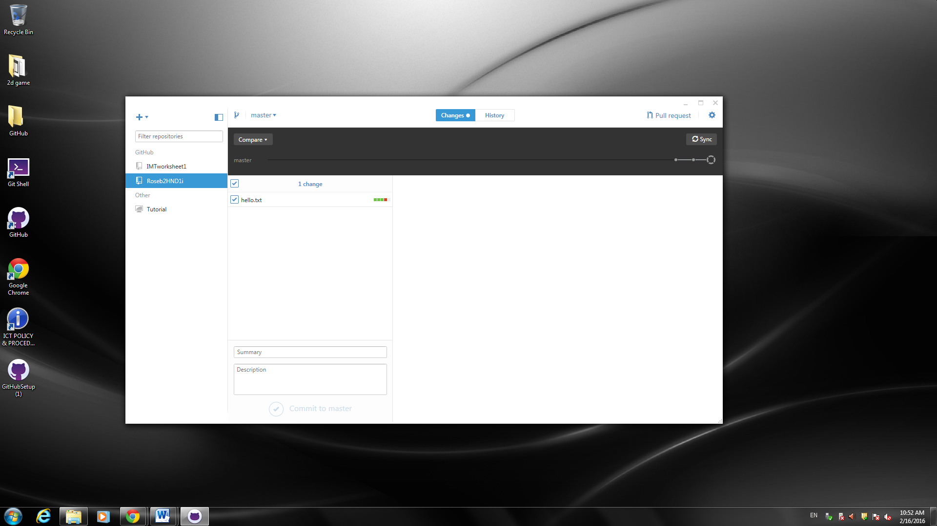

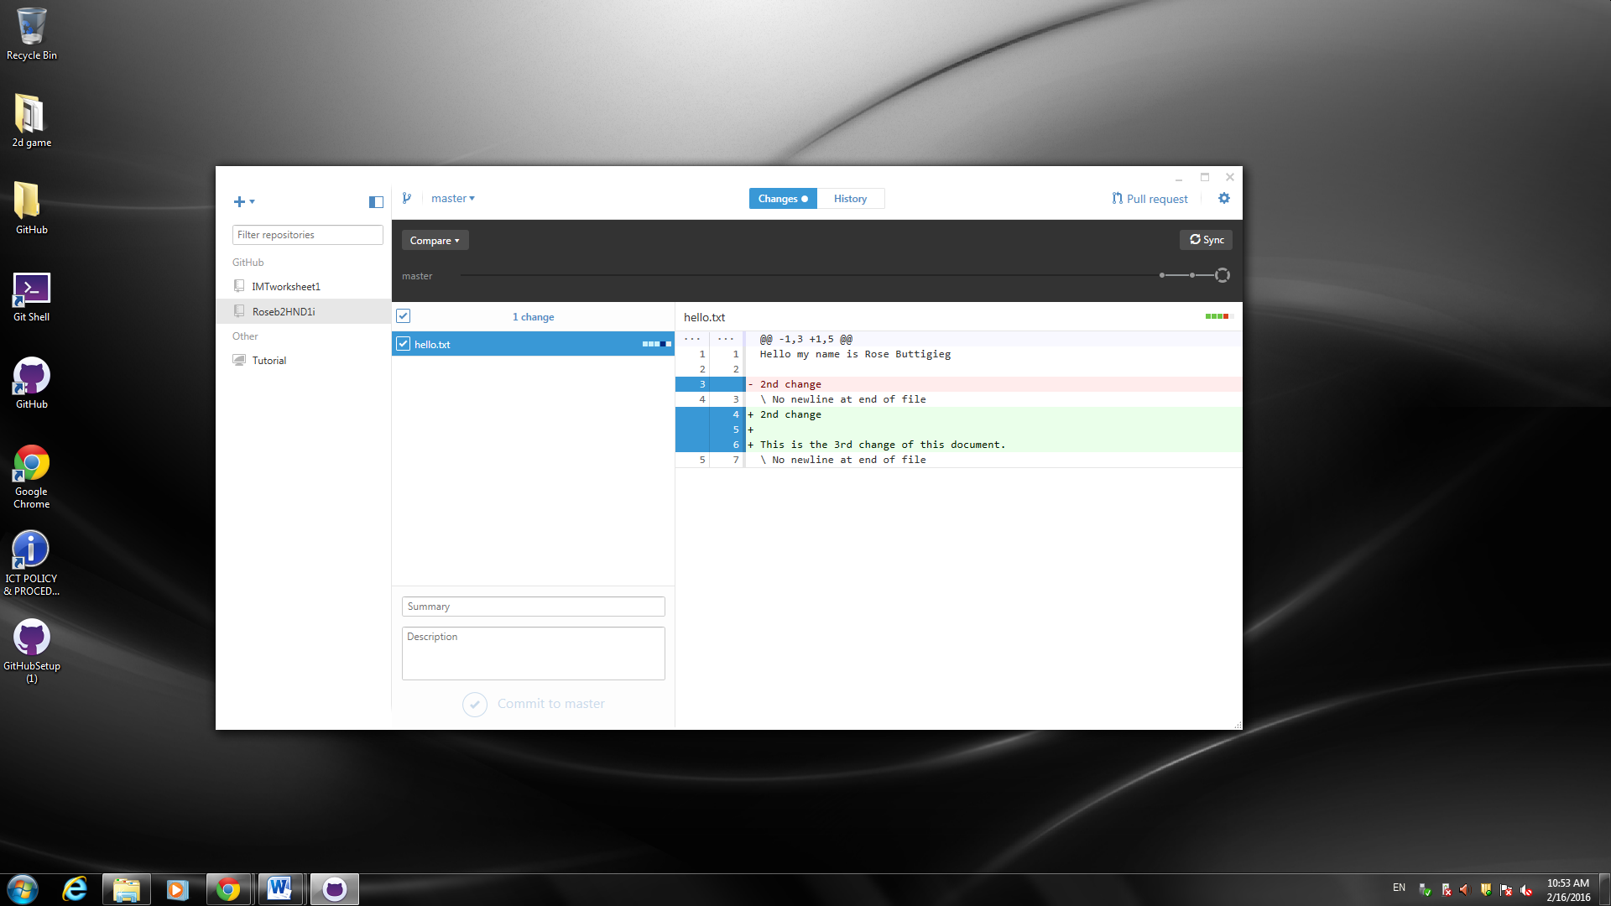

After you write a summary and a description of the change you made you can commit it, which will save the file also on GitHub.

Commit Description

This is a short description you write about the change you just made.

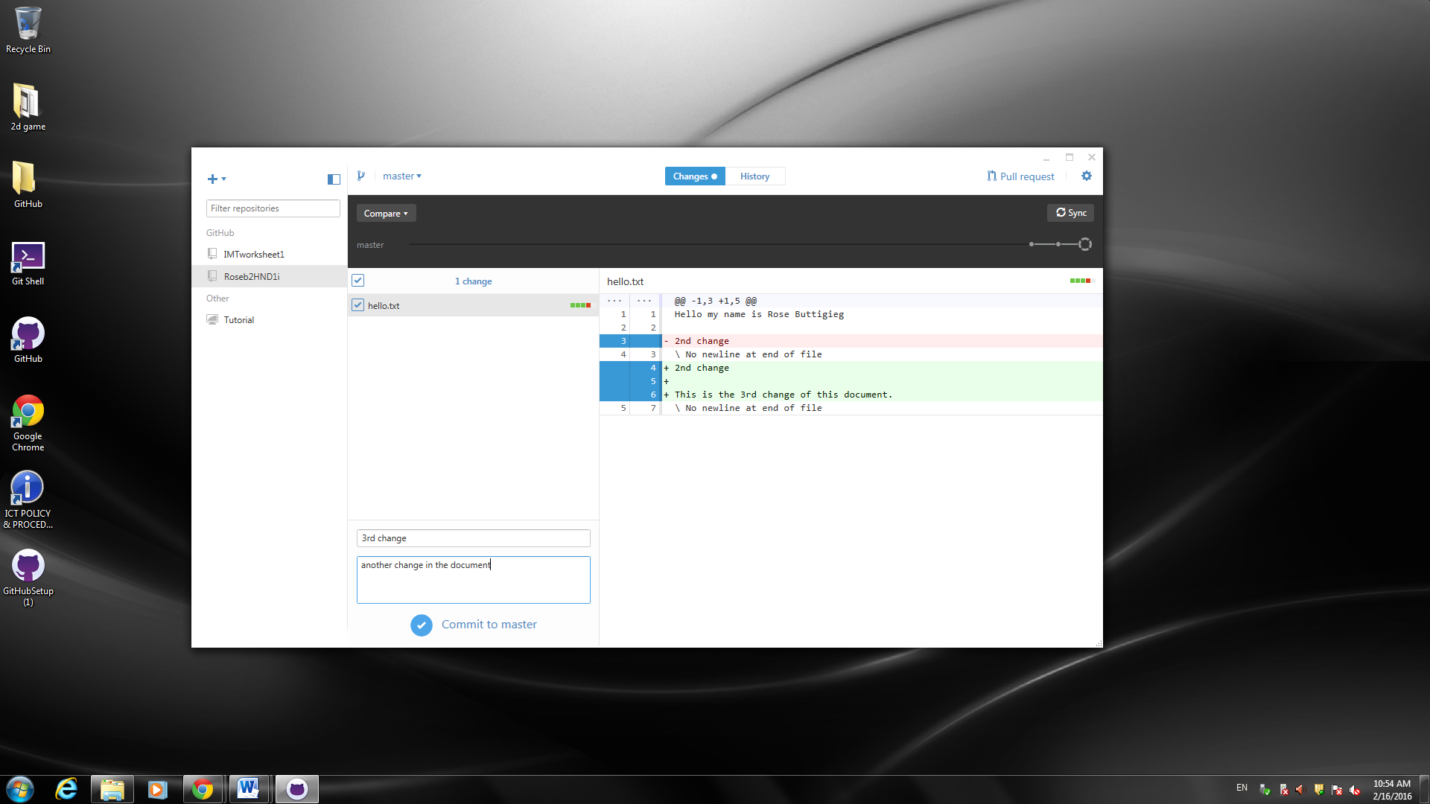

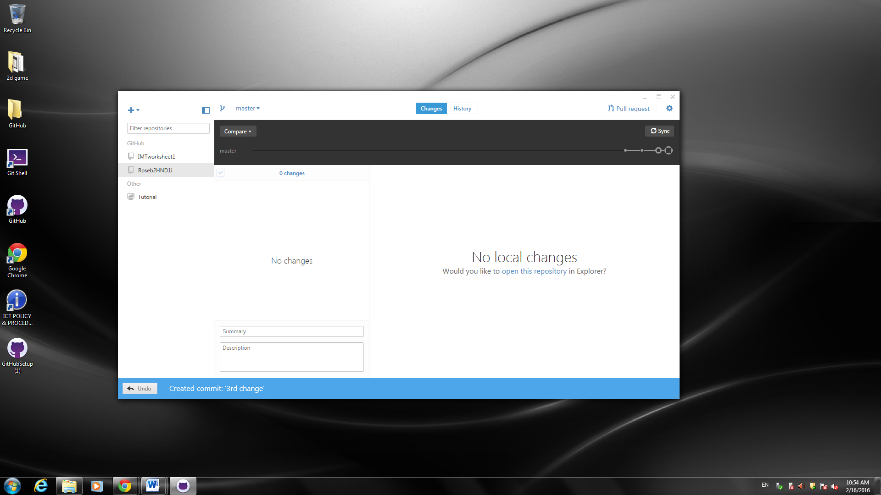

GitHub desktop

GitHub desktop is the software you can use which you save on your desktop to contribute to projects and files on GitHub, which allows you to commit changes and so on.

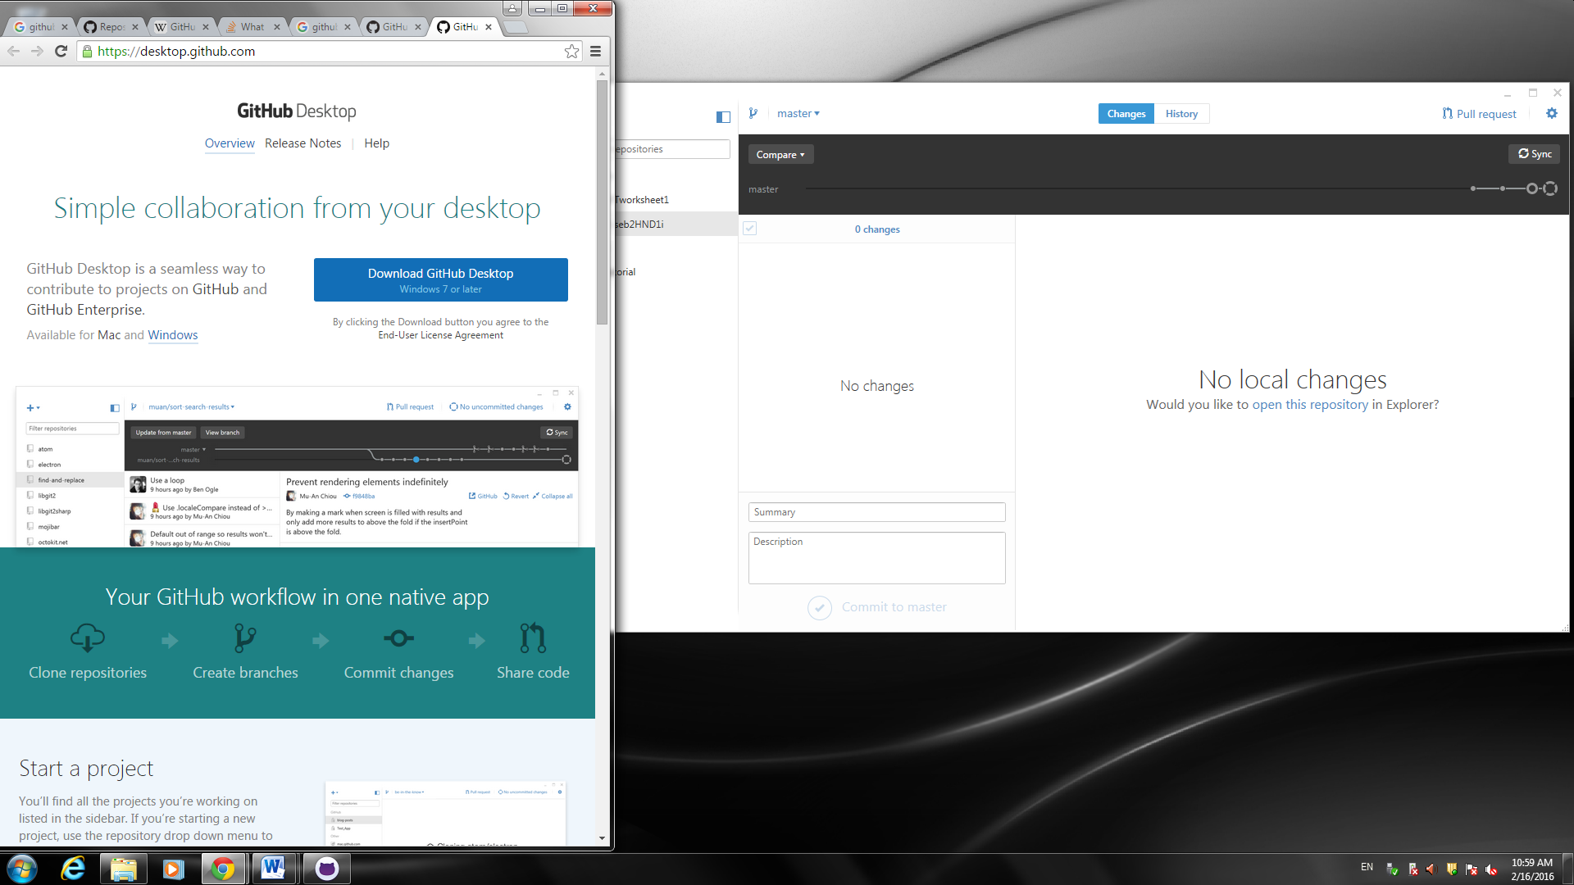



Git Sync

When you sync a file you are just basically saving your work and changes to GitHub, so that the file shown is the latest one, with all the changes made.

Before sync:

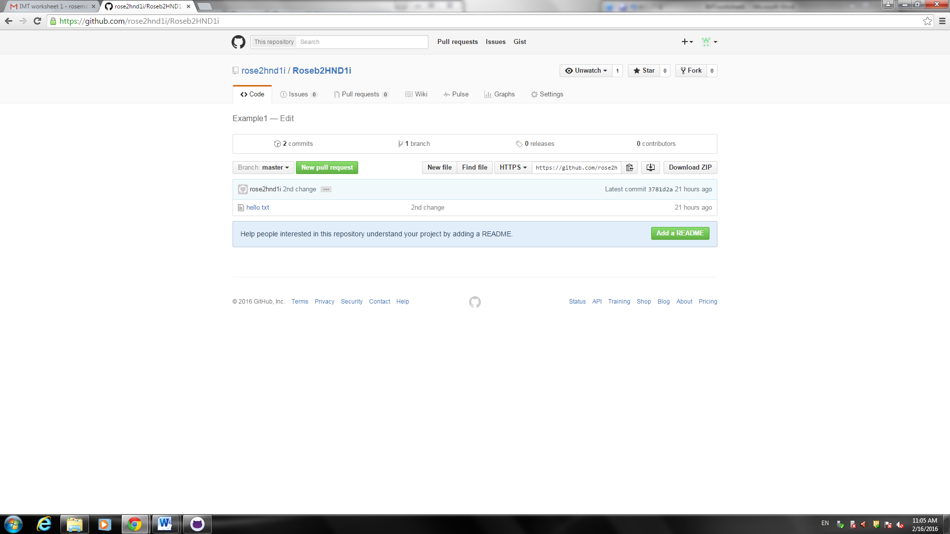

Sync:

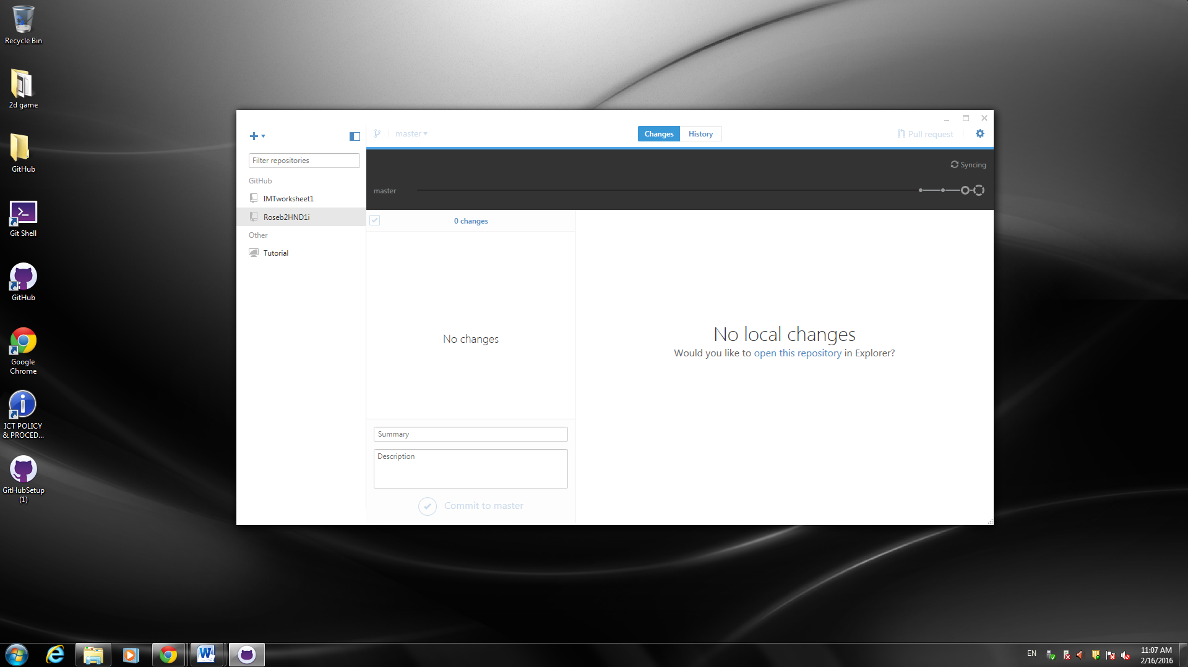

After sync:

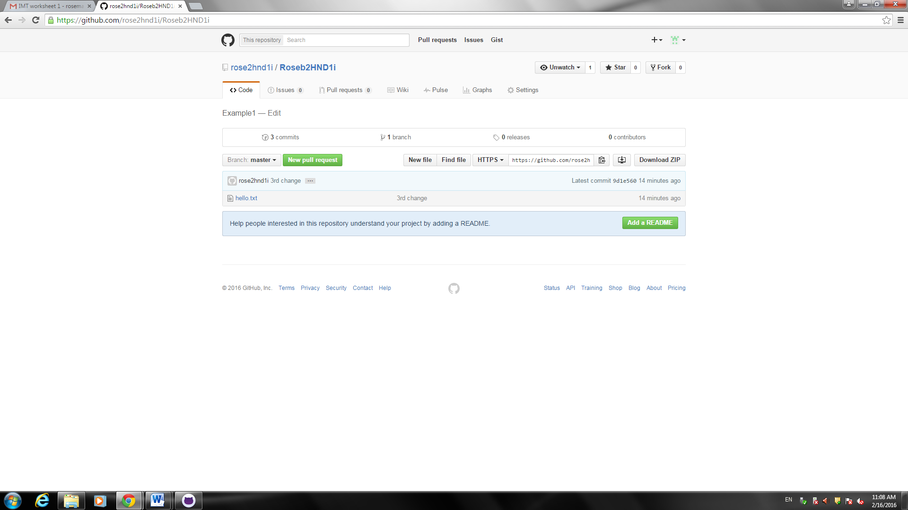

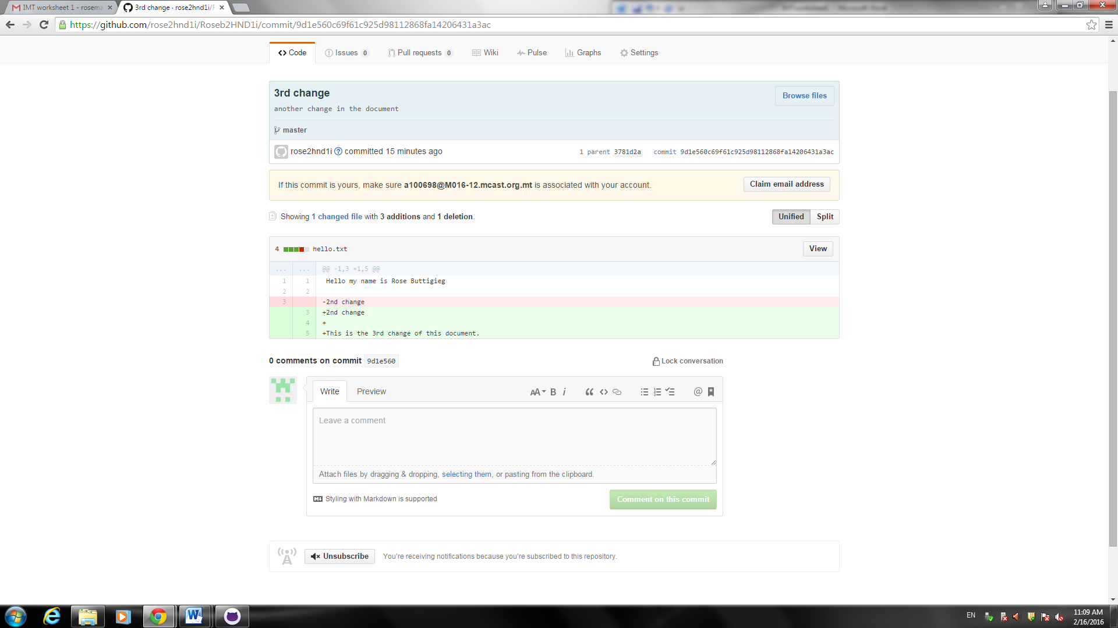

Download Zip

This is for people who want to download your project, but don’t need to change it. When you download the zip file you are not able to commit and sync changes.

